Sprint 3 - Agility Design Document

April 18, 2022

.
Table of Contents
1. Executive Summary 3
1.1 Project Overview 3
1.2 Purpose and Scope of this Specification 3
2. Product/Service Description 3
2.1 Product Context 3
2.2 User Characteristics 3
2.3 Assumptions 3
2.4 Constraints 3
2.5 Dependencies 4
3. Requirements 4
3.1 Functional Requirements 5
3.2 Security 5
3.2.1 Protection 5
3.2.2 Authorization and Authentication 6
3.3 Portability 6
4. Requirements Confirmation/Stakeholder sign-off 6
5. System Design 6
5.1 Algorithm 6
5.2 System Flow 6
5.3 Software 6
5.4 Hardware 6
5.5 Test Plan 7
5.6 Task List/Gantt Chart 7
5.7 Staffing Plan 7

Executive Summary

Project Overview
On this part of the project, Sprint 3, the robot needs to run the obstacle course. Within the obstacle course, includes avoiding bottles, jumping over the ramp, and lastly knocking down as many markers as possible.

Purpose and Scope of this Specification
The purpose of this test is to test how the robot can do when having obstacles challenge it. It must be able to handle a jump and other things in its path. Moving quickly and swiftly is the key for this sprint.

Product/Service Description

Product Context
This product has an accurate block code to fully complete the course and, in the end, have no real issue with getting around. It relies on angles to adjust itself so it can do a jump and get the most or all the pins.

User Characteristics
The people who would be using this robot would be:
- Ryan Huitzil, Student
- Alejandro Suarez, Student

Assumptions
There could be many problems with how the robot can run but the main one is quantity of supplies. The jump could also throw off the robot off course so it must make a speedy recovery.

Constraints
Some items that could constrain the design options are:
- Limit obstacle supplies
- Usage of course by others
- Robot malfunctions
- Block code error
- Low battery of robot

Dependencies
Some dependencies are:
- This new product will require the latest Sphero Edu app update
- Block code must be completed before testing

Requirements
Requirements for this Sprint are:
- Binder for jump – Priority 1
- Markers to knock down – Priority 2
- Bottles to avoid – Priority 2
- Fully charged Sphero – Priority 1
- Create Block Code – Priority 1
- Functional Block Code – Priority 1

Functional Requirements
Req# | Requirement | Comments | Priority | Date Rvwd | SME Reviewed / Approved
AGILI_01 | Robot must avoid bottles | Robot needs to avoid bottles to not get reduced points | 1 | 4/18 | Reviewed
AGILI_02 | Robot must jump the ramp and continue run without ruining the run | Robot needs to go at the right speed to not lose its track | 1 | 4/18 | Reviewed
AGILI_03 | Robot must knock down as many pins to complete the run and earn the victory | Must find the right spot or angle to be able to knock everything down | 1 | 4/18 | Reviewed

Security

Protection
There are many ways we can protect the data and block code made:
- encryption
- check activity logging
- Save block code
- Must not share password

Portability
- 100% Block Code
- 100% Obstacles completed

Requirements Confirmation/Stakeholder sign-off
Meeting Date | Attendees (name and role) | Comments
04/14/22 | Ryan H (Documenter) | Confirmed SDD
04/18/22 | Ryan H (Documenter) Alejandro S (Coder) | Ran tests and finished SDD

System Design
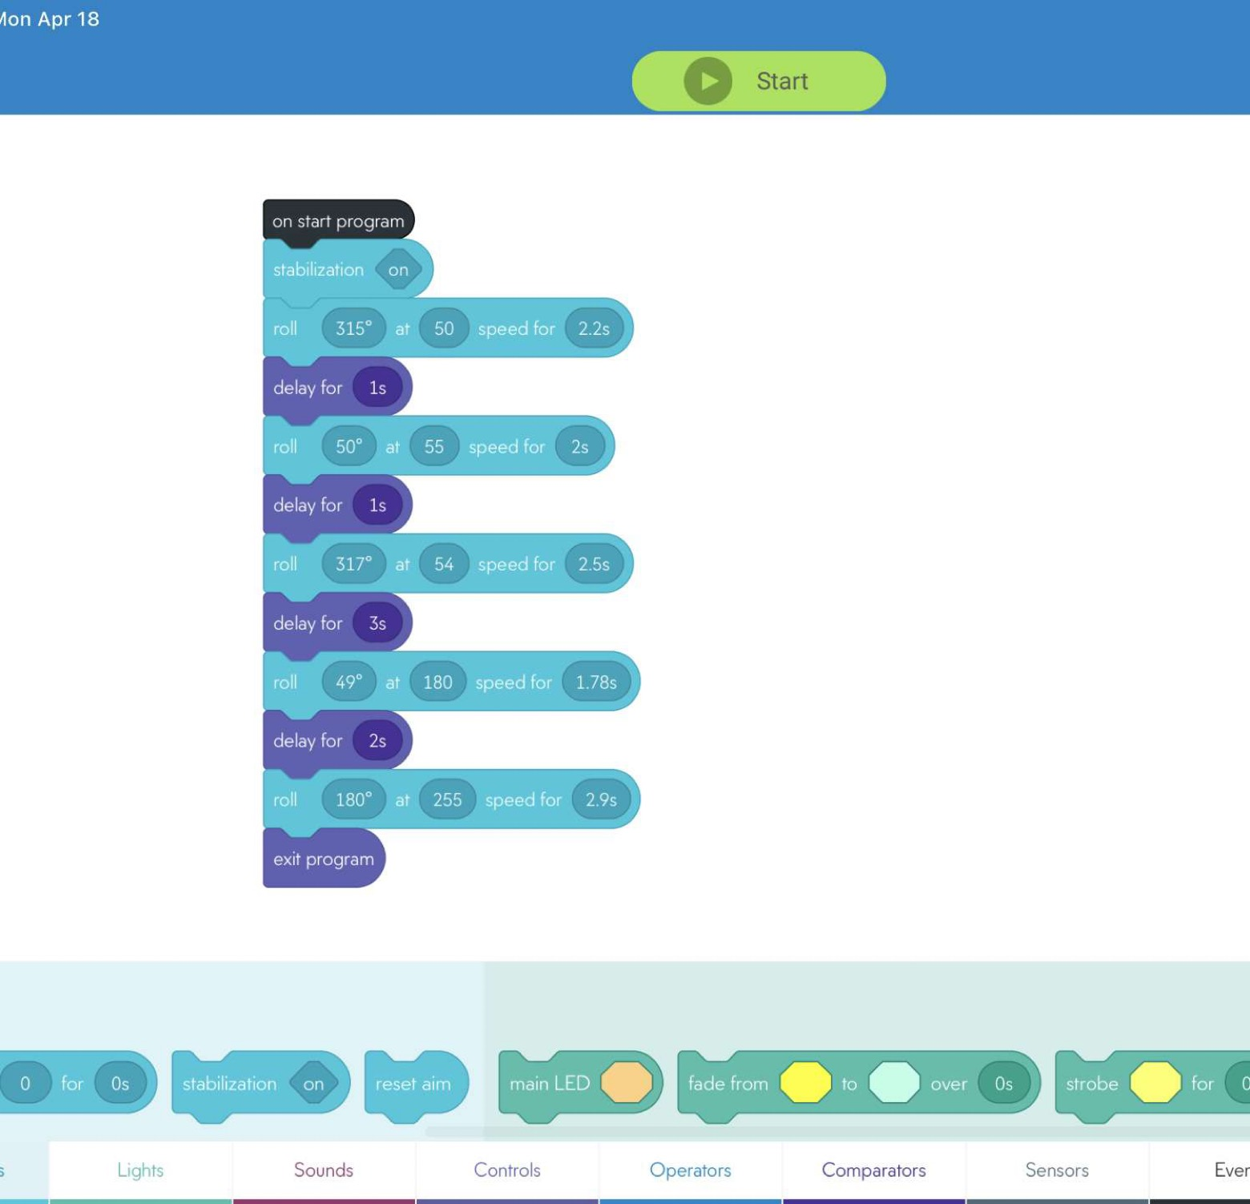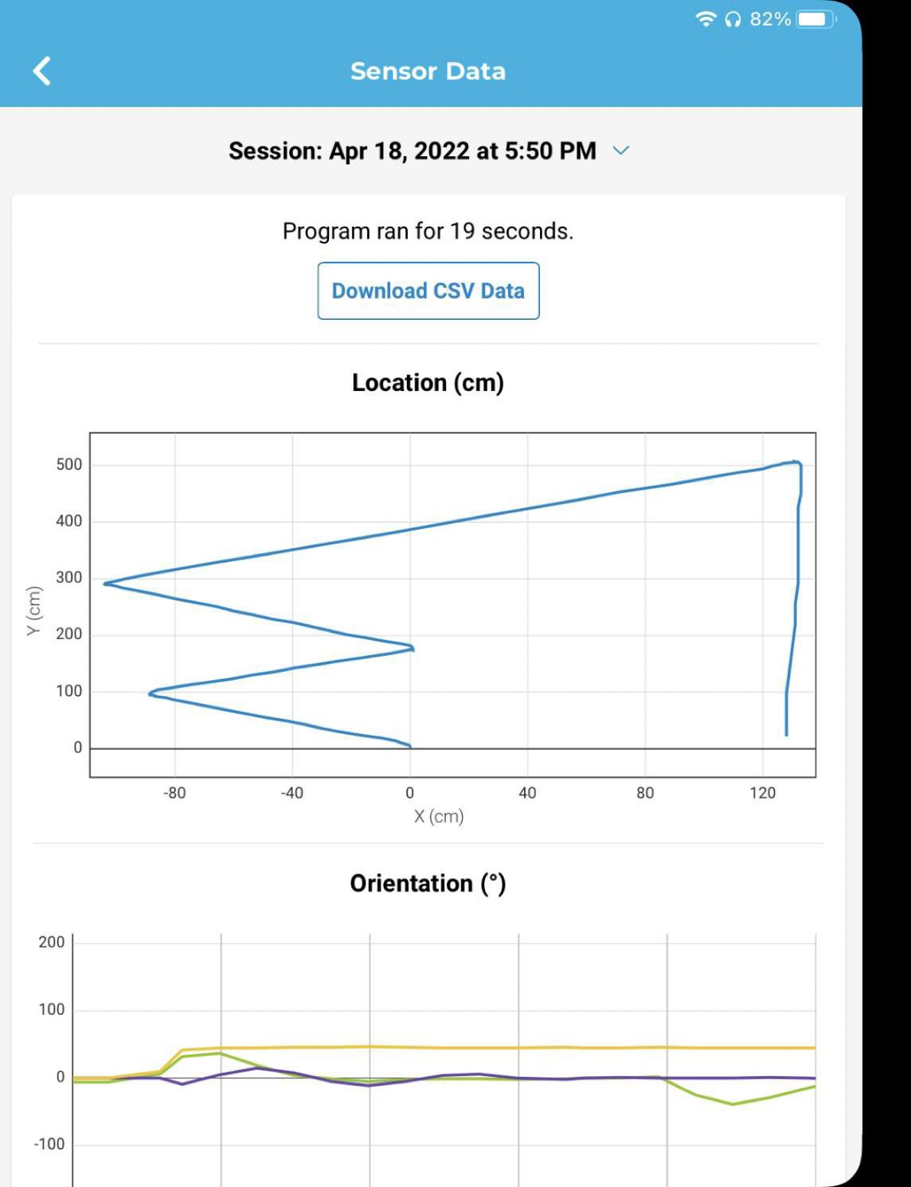

Algorithm
- Start Program
- Stabilization on
- Roll 315 degrees at 50 speed for 2.2 seconds
- Delay for 1s
- Roll 50 degrees at 55 degrees for 2 seconds
- Delay 1 second
- Roll 317 degrees at 54 degrees for 2.5 seconds
- Delay for 3 seconds
- Roll 49 degrees at 180 degrees for 1.78 seconds
- Delay for 2 seconds
- Roll 180 degrees at 255 degrees for 2.9 seconds
- End Program

System Flow
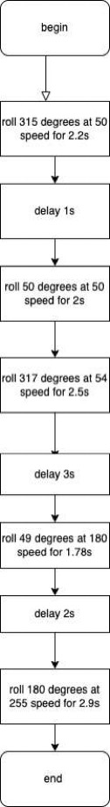

Software
Software used is the latest update of Sphero Edu to create and control robot

Hardware
Other than the robot being used in this course, it also included:
A binder for the jump
Bottles to move around and avoid
As many markers to knock down for the extra points

Test Plan

Reason for Test Case | Test Date | Expected Output | Observed Output | Staff Name | Pass/Fail
First run for robot to avoid bottles | 4/18 | Robot must avoid first bottle | Robot avoided first obstacle | Alejandro | Pass
Robot must continue to next bottle | 4/18 | Robot continues run to move forward on the obstacle course | Robot was successful | Alejandro | Pass
Robot must hit a zigzag to go to ramp jump | 4/18 | Robot must reach ramp to continue | Robot passed and is ready to continue | Alejandro | Pass
Robot’s first run on ramp | 4/18 | Robot must complete ramp jump | Robot fell back due to its speed | Alejandro | Fail
Attempt 2 on ramp jump | 4/18 | Robot must jump ramp | Robot is successful | Alejandro | Pass
Must make a recovery and go straight to hit pins | 4/18 | Robot must adjust to hit pins | Robot was unsuccessful | Alejandro | Fail
Robot needs to adjust to continue | 4/18 | Sphero must be at the right angle to continue | Robot made a better recovery and is ready to move on | Alejandro | Pass
Robot must hit pins | 4//18 | Robot should be ready to hit pins | Robot knocked all the pins | Alejandro | Pass

Task List/Gantt Chart
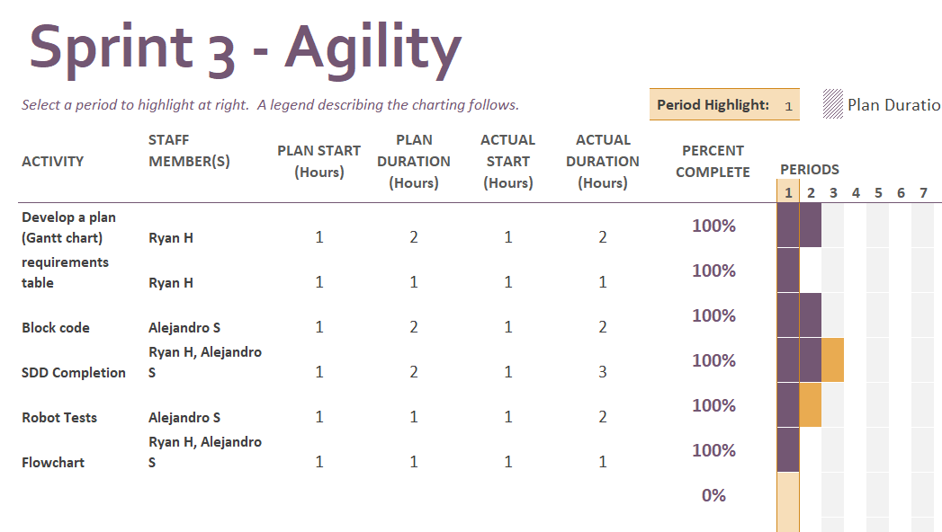

Staffing Plan
Name | Role | Responsibility | Reports To
Ryan H | Documenter | Complete SDD and everything required on it
Alejandro S | Coder | Block code and Flowchart | Ryan H

